**SHELL PROGRAM LIST**

1. Write a shell script to find out the greatest among three inputs.

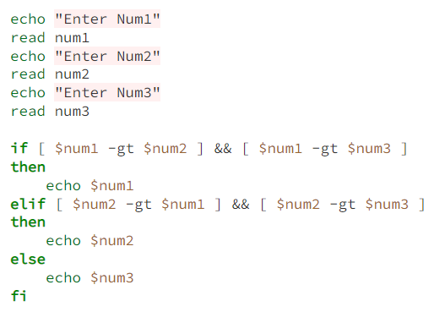

1. Write a shell script for swapping of two numbers without using any third variable

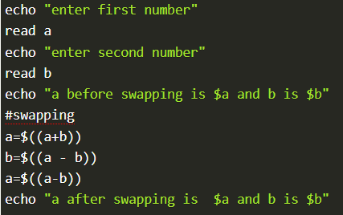

1. Write a shell script to find whether an input year is leap year or not.

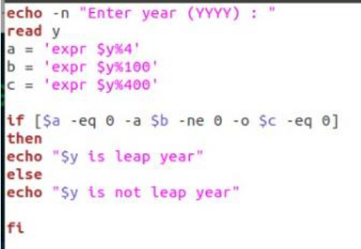

1. Write a shell script that accepts a file name, starting and ending line numbers as arguments and display all the lines between the given line numbers?

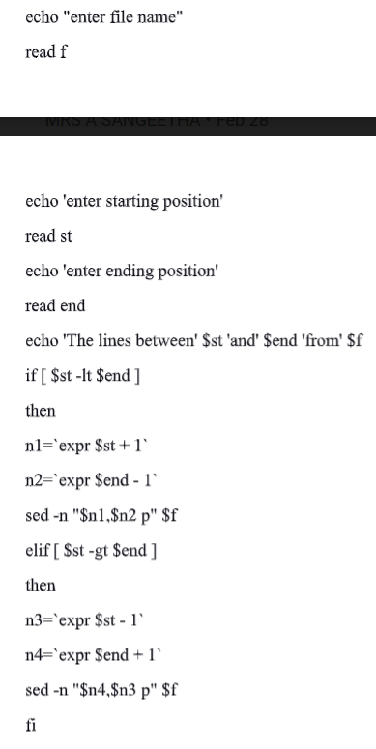

1. Write a shell script for swapping of two numbers without using any third variable

Refer Ques 2

1. Write a shell script to print all the multiplication tables(upto10) between two given numbers.

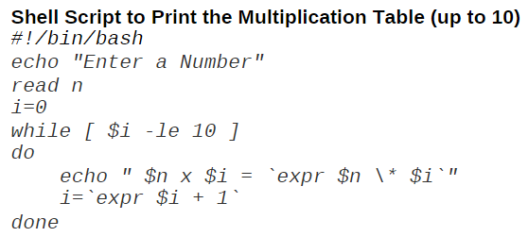

1. Write a shell script to find out the factorial of an input.

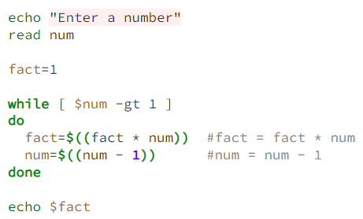

1. Write a shell script to check whether an input is a prime or not.

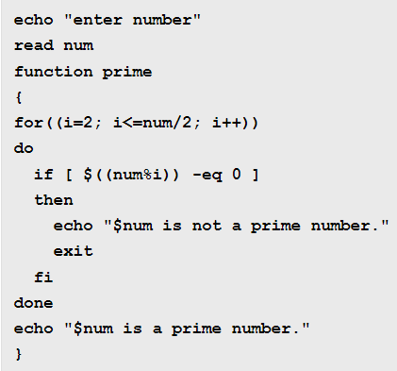

1. Write a shell script to generate the primes between two given numbers.

Use for loop in 8 ques.

1. Write a shell script to display a three-digit number in English words.

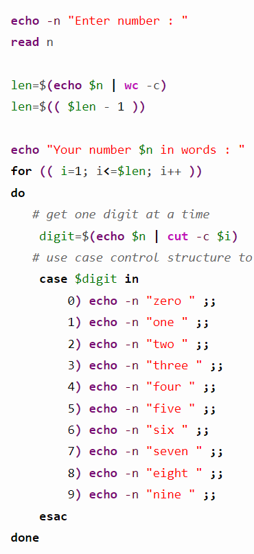

1. Write shell script that accepts a file name, starting and ending line numbers as arguments and display all the lines between the given line numbers.

Refer Ques 4

1. Write a shell script to read an integer and print its digits in reverse order.

Read the value of n using “read n” command.

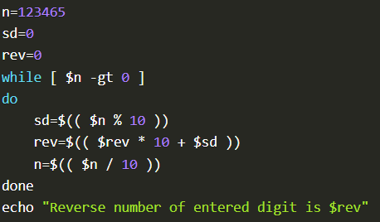

1. Write a shell script for swapping of two numbers without using any third variable

Refer Ques 2

1. Write a shell script to print Fibonacci series.

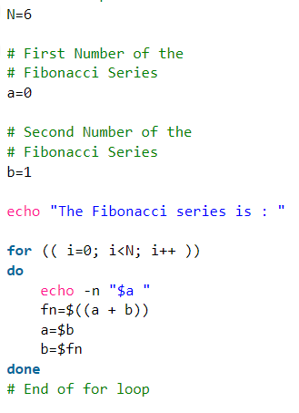

1. Write a shell script to read an integer and print its digits in reverse order.

Refer Ques 12

1. Write a shell script that accepts a file names as its arguments, counts and reports the occurrence of each word that is present in the file argument file in other argument files.

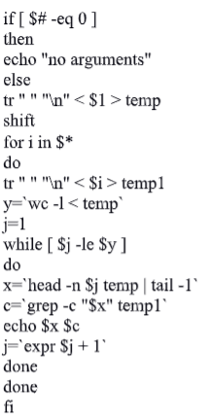

1. Write a shell script to generate the primes between two given numbers.

Use for loop in 8th ques.

1. Write a shell script to the given number is Armstrong numbers or not?

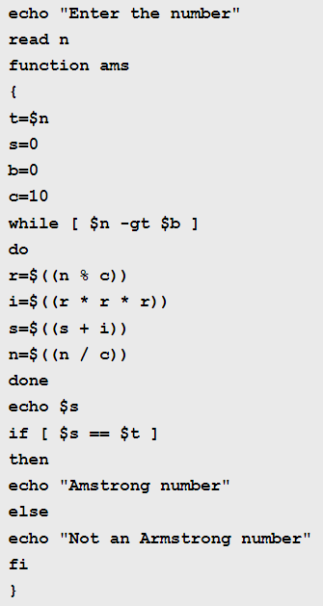

1. Write a shell script to accepting student name, and calculate total, average and result?

clear

echo -----------------------------------

echo '\tStudent Mark List'

echo -----------------------------------

echo Enter the Student name

read name

echo Enter the Register number

read rno

echo Enter the Mark1

read m1

echo Enter the Mark2

read m2

echo Enter the Mark3

read m3

echo Enter the Mark4

read m4

echo Enter the Mark5

read m5

tot=$(expr $m1 + $m2 + $m3 + $m4 + $m5)

avg=$(expr $tot / 5)

echo -----------------------------------

echo '\tStudent Mark List'

echo -----------------------------------

echo "Student Name : $name"

echo "Register Number : $rno"

echo "Mark1 : $m1"

echo "Mark2 : $m2"

echo "Mark3 : $m3"

echo "Mark4 : $m4"

echo "Mark5 : $m5"

echo "Total : $tot"

echo "Average : $avg"

if [ $m1 -ge 35 ] && [ $m2 -ge 35 ] && [ $m3 -ge 35 ] && [ $m4 -ge 35 ] && [ $m5 -ge 35 ]

then

echo "Result : Pass"

if [ $avg -ge 90 ]

then

echo "Grade : S"

elif [ $avg -ge 80 ]

then

echo "Grade : A"

elif [ $avg -ge 70 ]

then

echo "Grade : B"

elif [ $avg -ge 60 ]

then

echo "Grade : C"

elif [ $avg -ge 50 ]

then

echo "Grade : D"

elif [ $avg -ge 35 ]

then

echo "Grade : E"

fi

else

echo "Result : Fail"

fi

echo -----------------------------------

1. Write a shell script to compare two strings are equal or not?

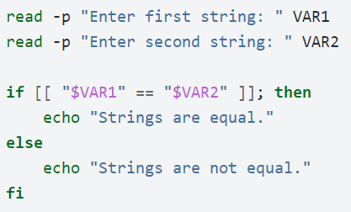

**LINUX COMMANDS**

**1. Execute following commands**

**a) cp b) mv c)wc**

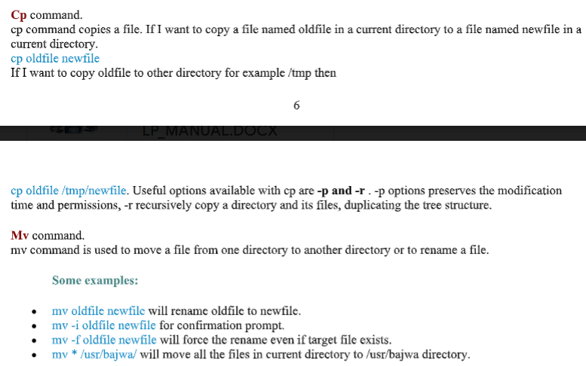

**WC-command-**

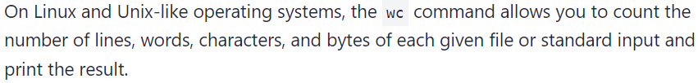

Ex- wc /proc/cpuinfo

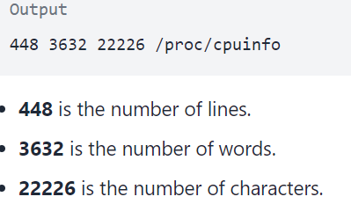

**2. Execute following commands**

**a) head b) tail c) sort**

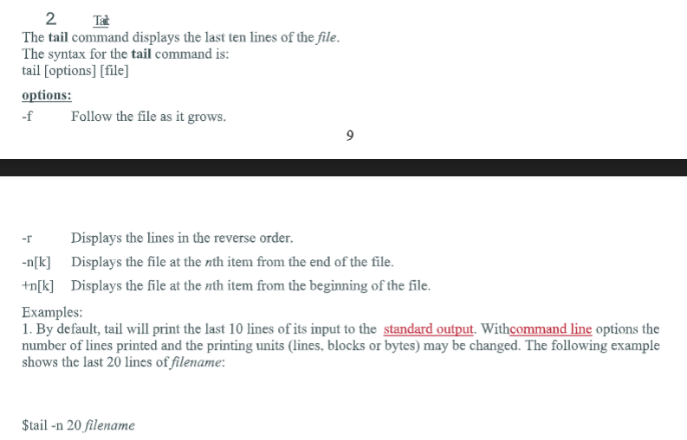

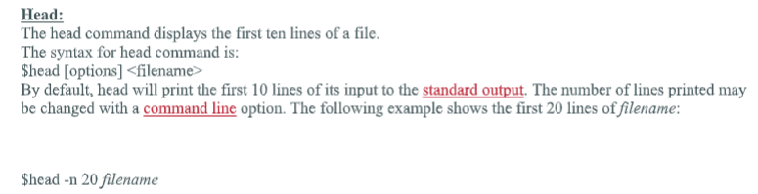

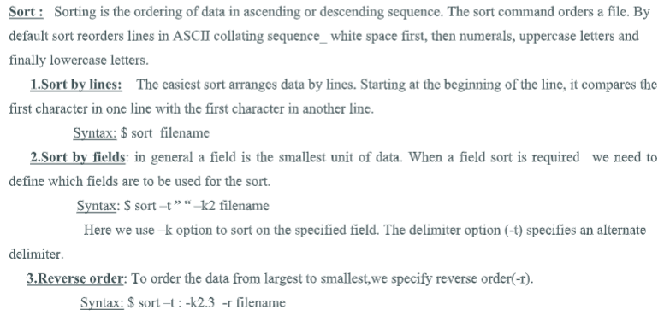

**3. Execute following commands**

**a) grep b) egrep c) diff**

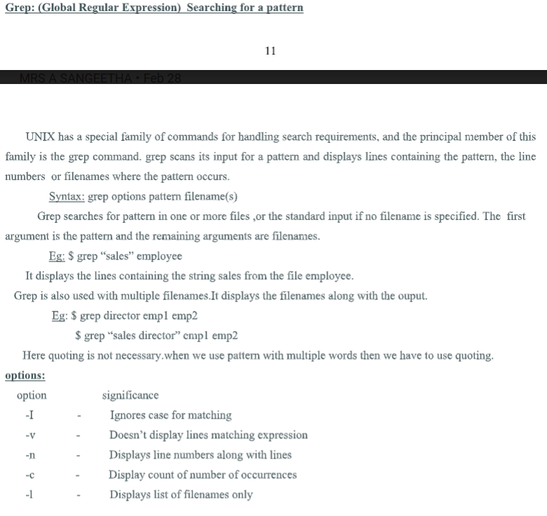

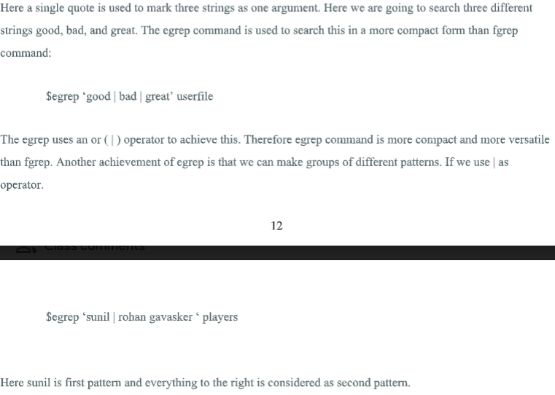

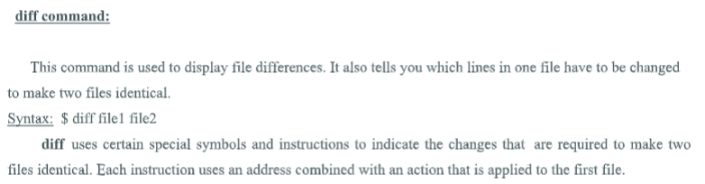

**4. Execute following commands**

**a) tar b) join c) paste**

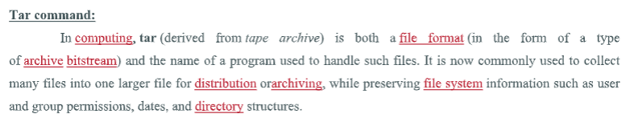

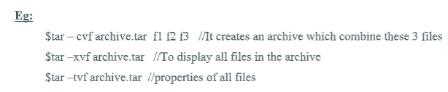

**Join ---🡪Refer no-5 !!**

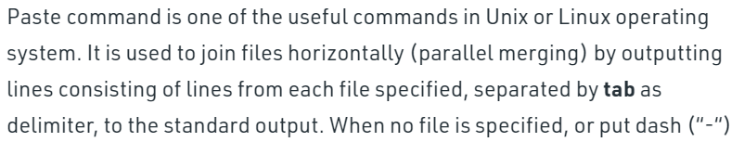

**Syntax- paste [options]… [Files]…**

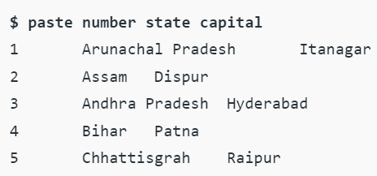

**5. Execute following commands**

**a) tr b) join c) cut**

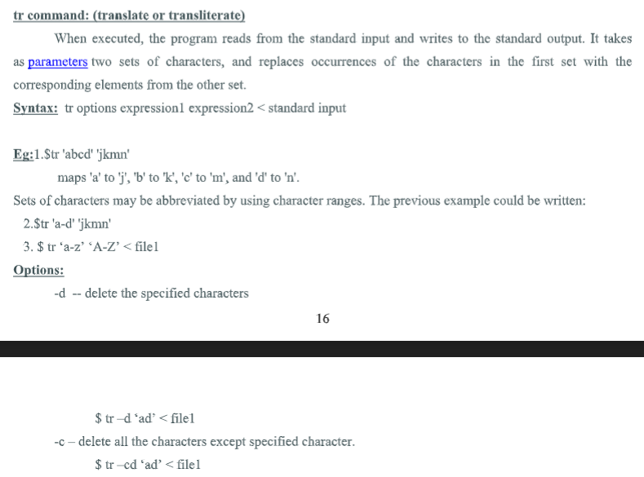

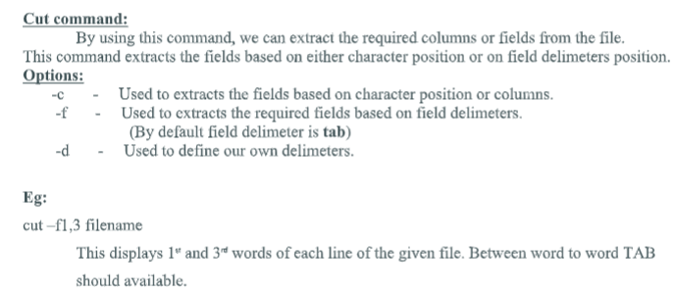

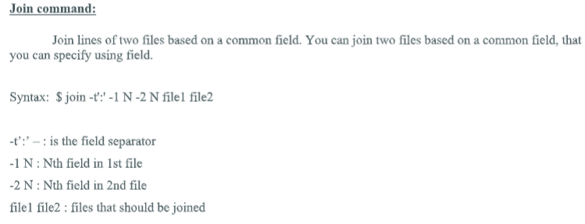

**6. Execute following commands**

**a) ps b) df c) du**

